
ISLAMIC UNIVERSITY OF TECHNOLOGY (IUT)
ORGANISATION OF ISLAMIC COOPERATION (OIC)
DEPARTMENT OF ELECTRICAL AND ELECTRONIC ENGINEERING

NAME : Shazzad Ahmed STUDENT ID : 220021108
DEPARTMENT : EEE SECTION & GROUP : A_2

DATE OF SUBMISSION : 20-08-25

COURSE NO. : EEE4404
COURSE TITLE : COMMUNICATION ENGINEERING I LAB

EXPERIMENT NO : 05
NAME OF EXPERIMENT: TIME-DIVISION MULTIPLEXED PAM COMMUNICATION

Theory :
Pulse modulation is a technique used to send analog signals in the form of electrical pulses. In its simplest type, Pulse Amplitude Modulation (PAM), the height of each pulse represents the value of the analog signal at specific sampling moments, with a clock signal ensuring proper timing.
PAM works well with Time Division Multiplexing (TDM), where several signals share one communication channel by transmitting in quick sequence. The gaps between PAM pulses allow other signals to be inserted, making it an efficient method for multi-channel communication.
Experiment:
In this experiment, the Emona Telecoms-Trainer 101 is used to study PAM and TDM. The work starts with building a single-channel PAM transmitter to see how an analog signal is sampled and represented by pulses. The system is then expanded to two channels, showing how TDM combines multiple signals into one transmission. Afterward, the multiplexed signals are separated and recovered to confirm accurate operation. Finally, speech signals are transmitted and reconstructed, highlighting the real-world use of PAM and TDM in communication systems.
Data Collection :
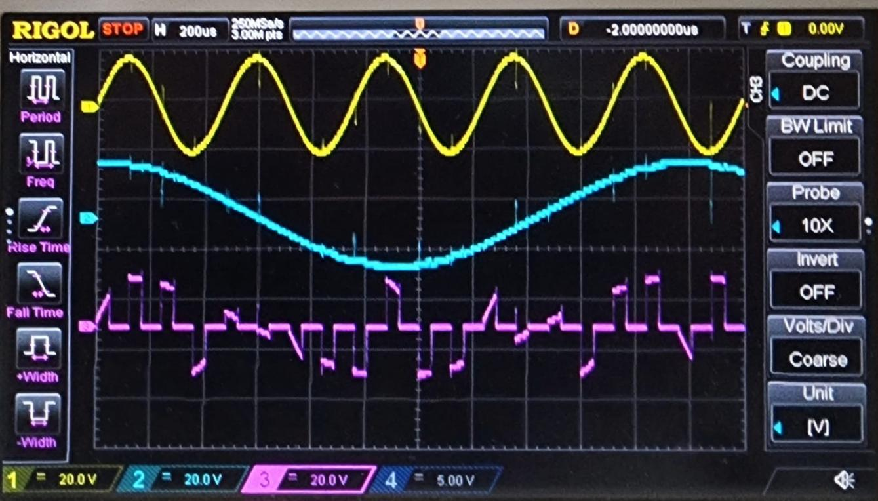
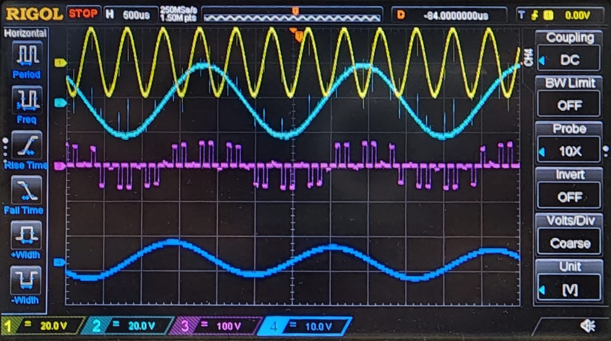
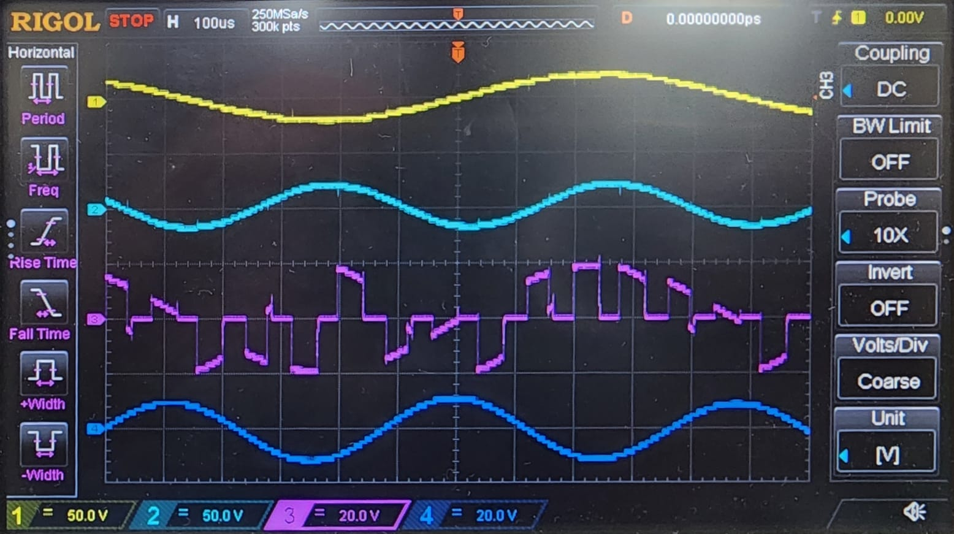

Result Analysis :
The oscilloscope display provides clear evidence of the PAM experiment results. The yellow and cyan traces (CH1 and CH2) show the analog input signals, likely sine waves, which serve as the original message signals. The magenta trace (CH3) represents the generated PAM signal. It consists of pulses whose amplitudes follow the variations of the input signal, confirming that the analog waveform is being sampled at regular intervals. The blue trace (CH4) shows another sine wave, likely included as a reference or comparison.
Overall, the PAM waveform matches expectations: the sampling process preserves the shape of the original message, demonstrating that the modulation was successfully carried out in the practical setup.
Report Questions__
1.
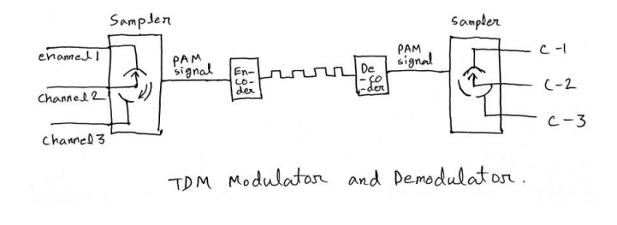

2.

Advantages of Pulse Amplitude Modulation (PAM):
- Bandwidth Efficiency: Makes effective use of available bandwidth.
- Simple Design: Straightforward to implement and operate.
- Low Cost: Economical in terms of production and operation.
- Flexible Allocation: Supports adaptable distribution of signals.
Disadvantages of Pulse Amplitude Modulation (PAM):
- Synchronization Challenges: Maintaining timing between transmitter and receiver is difficult.
- Limited Scalability: Less effective for large or expanding communication networks.
- Fixed Allocation: Lacks dynamic adaptability under changing network conditions.
Conclusion :
In this experiment, Pulse Amplitude Modulation (PAM) was introduced and implemented to generate PAM signals in practice. Time Division Multiplexing (TDM) was then examined to demonstrate how multiple signals can be transmitted simultaneously over a single channel. Finally, the advantages and disadvantages of these modulation methods were analyzed.

